Facebook
- Did you know that the carotid arteries are responsible for up to a third of strokes? Ask your physician if you should be screened. It could possibly save your life. #stopstroke #DontWait #DontWaitForAStroke [add ⅓ infographic] [link to hospital carotid disease webpage]
- Do you have two or more of these risk factors? If so, you may be at risk for a stroke. Even during the #COVID pandemic, it is important to take charge of your health and get the care you need. Talk to your doctor about getting a carotid artery screening. #stopstroke #DontWait #DontWaitForAStroke [add risk factor infographic] [link to hospital carotid disease webpage]
- During this pandemic, [Hospital] is dedicated to providing a safe environment to ensure you can continue getting the care you deserve. This includes offering minimally invasive treatment options such as #TCAR which is clinically proven to lower patients’ risk for stroke with a faster recovery, less pain and smaller scars. #stopstroke #wereinthistogether [TCAR infographic - stop strokes before they happen?] [link to hospital TCAR Page or www.youtube.com/watch?v=O32nDoovMPY&t=]
- Take charge of your health and stop stroke before it happens. Here are 5 ways you can prevent stroke. #stopstroke #DontWait #DontWaitForAStroke [5 ways to prevent stroke infographic] [link to stroke preventative blog post/newsletter]

Twitter
- Did you know that the carotid arteries are responsible for up to a third of strokes? Ask your physician if you should be screened. It could possibly save your life. #stopstroke #DontWait #DontWaitForAStroke [add ⅓ infographic] [link to hospital carotid disease webpage]
- Do you have two or more of these risk factors? If so, you may be at risk for a stroke. Even during the #COVID pandemic, it is important to take charge of your health and get the care you need. Talk to your doctor about getting a carotid artery screening. #stopstroke #DontWait #DontWaitForAStroke [add risk factor infographic] [link to hospital carotid disease webpage]
- [@Hospital] is dedicated to providing a safe environment to ensure you get the care you deserve. This includes offering minimally invasive treatment options such as #TCAR - clinically proven to lower the risk for stroke with faster recovery. #stopstroke #wereinthistogether [TCAR infographic - stop strokes before they happen?] [link to hospital TCAR Page or www.youtube.com/watch?v=O32nDoovMPY&t=]
- Take charge of your health and #stopstroke before it happens. Here are 5 ways you can prevent stroke. [5 ways to prevent stroke infographic] [link to stroke preventative blog post/newsletter]

Sample Graphics to leverage w/posts:
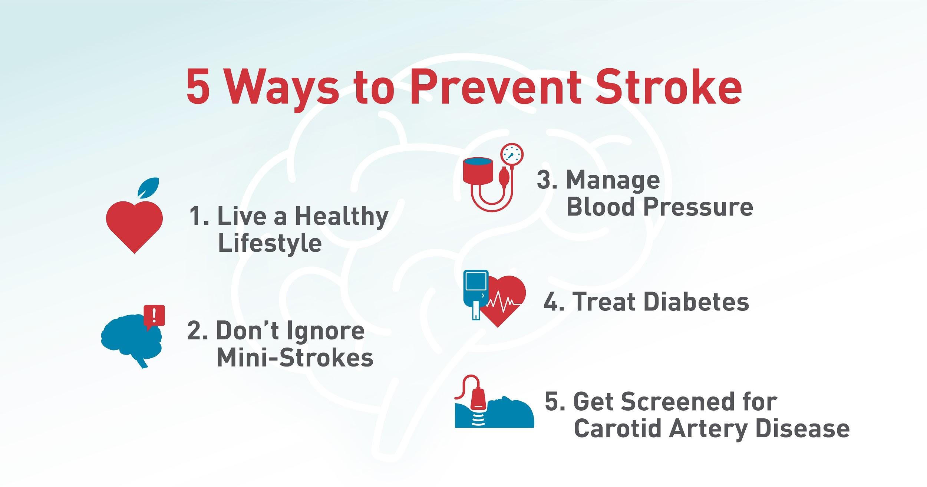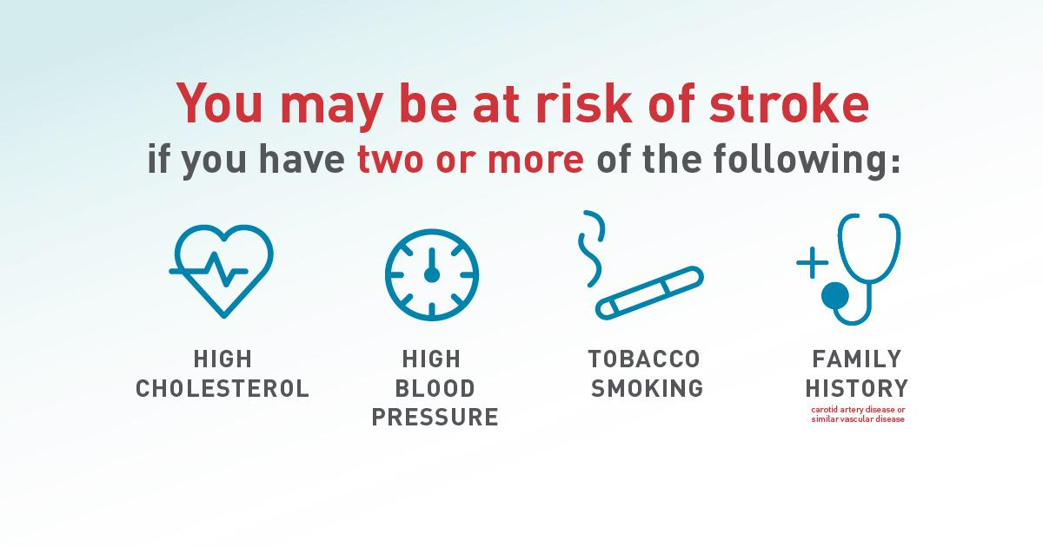

[If you would like to include an animation video of the procedure, it can be linked from https://youtu.be/O32nDoovMPY]

# # # Sample Social Media Posts # # #

