Therapy Awareness & Patient Engagement Kit:
Stroke Prevention During the COVID-19 Pandemic
Educating your community not to ignore the risk factors for stroke and the precautions your facility
is taking to prevent the spread of COVID-19.

Silk Road Medical, Inc. is pleased to share with you this stroke prevention marketing kit, which is designed to supplement our standard public relations kit (Link). This kit contains customizable materials to help you educate patients on how to prevent stroke, the TransCarotid Artery Revascularization (TCAR) procedure, and your COVID-19 safety protocols. Please note the use of these materials is strictly voluntary, and you are not obligated to purchase Silk Road Medical products. This kit includes:

- Press Release Template
This customizable press release template is partially pre-written for you to use to educate the community on the importance of seeking immediate care to prevent a stroke, your COVID-19 safety protocols, and TCAR. There are placeholder sections for you to add your information and send to your local media outlets.
- Newsletter Content
We have provided pre‐written content for your community newsletter or blog. The content can also be repurposed as a bylined article and sent to a local newspaper or magazine that does not have the bandwidth to write an original piece. If possible, the article would be richer if you are able to insert one of your patient’s stories in the designated sections (with the patient’s consent). We recommend sharing successful patient stories after patients have had a bit of time to heal.

- Sample Social Media Posts
These customizable posts for your Facebook and/or Twitter accounts can help people discover your practice or hospital and drive traffic to your website. If you do not have existing copy on your website, draft copy is available in our standard public relations toolkit.
- Referring Physician Letter/Email
This letter can be customized and sent to your referral base.

- Carotid Artery Disease Backgrounder
This backgrounder provides an overview of carotid artery disease and available treatments to leverage when developing stories.
- Physician & Patient Testimonial Guide
This guide includes helpful media tips, prompt questions, and suggested messaging for both the physician and patient.

If you have any questions or would like a copy of our standard public relations toolkit, please contact us.

Best regards,

Michael Fanucchi
Director, Marketing Communications
Silk Road Medical
mfanucchi@silkroadmed.com
P: 408-585-2169

Caution: Federal (USA) law restricts this device to sale by or on the order of a physician.
Please refer to package insert for indications, contraindications, warnings, precautions, and instructions for use.
Every Second Counts When It Comes to Stroke
[Hospital Name] Saving Lives During the COVID-19 Pandemic by Preventing Stroke with the TCAR Procedure
[CITY, State] – [Date] – As the novel COVID-19 pandemic sweeps the nation, [Hospital Name] has implemented numerous protocols to stop the spread of the virus and protect patients during this crisis. People’s day-to-day activities have drastically changed to safeguard themselves from the virus, but there is one thing people should not avoid due to the COVID-19 virus – delaying care for life-threatening conditions such as carotid artery disease which may lead to a stroke.
Strokes still happen during a pandemic. In fact, every 40 seconds, someone in the United States has a stroke. Worldwide, nearly 6 million die from a stroke and another 5 million are left permanently disabled every year. Yet, there was a 40% decline in patients seeking stroke evaluations during the COVID-19 pandemic (cite). Even with the fear of COVID-19, it is crucial to get care as soon as possible to prevent the chance of a future stroke. With up to a third of strokes caused by carotid artery disease, [Hospital Name] offers patients minimally invasive options such as TransCarotid Artery Revascularization (TCAR) to prevent future strokes with a faster recovery time and an increased chance of being discharged to home¹.
[Patient Name] took action to protect [his/her] health and sought immediate care once [he/she] was diagnosed with carotid artery disease. Even during a pandemic, [Patient Name] was not going to risk the chance of having a stroke.
PATIENT QUOTE (if available): “[Hospital] made me feel safe getting treated for my disease. I didn’t want to wait to get the TCAR procedure done and increase my chance of getting a stroke. The procedure was easy compared to the other surgeries I’ve had, and the recovery was much faster,” said [Patient Name], who was considered too risky for traditional surgery. “I was out of the hospital the day after the procedure with a much smaller scar than I expected. I feel great and am looking forward to getting the other side done very soon.”
Prior to TCAR, the main treatment option for severe carotid artery disease was an open surgical procedure called carotid endarterectomy (CEA). CEA removes plaque from inside the carotid artery to restore normal blood flow to the brain, but the large incision leaves a visible scar the length of the neck and carries risks of surgical complications, including bleeding, infection, heart attack and cranial nerve injuries that can cause issues with swallowing, speaking and sensation in the face.
SAMPLE QUOTE: “We are taking every precaution to ensure the safety of our patients during this pandemic, and TCAR is an important patient option in the fight against stroke,” said Dr. [Name, title]. “Because of its low stroke risk and faster patient recovery, I believe TCAR represents the future of carotid repair.”
[Hospital Name] has taken extra safeguards to ensure the safety of their patients from COVID-19 by:
- [insert hospital COVID protocols].
The TCAR procedure was developed by Sunnyvale, California-based Silk Road Medical, Inc. and includes the ENROUTE® Transcarotid Neuroprotection (NPS) and Stent System – the first devices designed and FDA-approved specifically for TCAR. Over 15,000 TCAR procedures have been performed worldwide through clinical trial and commercial use. TCAR has been studied extensively, and the clinical data have been excellent. Additional information about TCAR is available at http://silkroadmed.com/disease-and-treatment-options/.

About [Hospital]
[Insert Boilerplate]
### Press Release Template ###
¹M. Malas, MD; VAM Presentation 2019
---------------------------
Sources:
https://vascular.org/patient-resources/vascular-conditions/carotid-artery-disease
https://www.cdc.gov/stroke/facts.htm
https://www.world-stroke.org/world-stroke-day-campaign/why-stroke-matters/learn-about-stroke
Stroke Prevention During the COVID-19 Pandemic: Don’t Delay Care
Strokes affect well over 700,000 people in the United States every year with over 100,000 of these individuals passing away from this medical emergency. With early action being one of the key indicators for surviving strokes, it is vital to recognize the symptoms (FAST: Face, Arm, Speech, and Time) and stop stroke before it happens through preventative measures.
While there are many different causes of stroke, there are simple things one can do to prevent stroke, or at least significantly reduce the likelihood of a stroke leading to permanent disability or death. After all, the American Stroke Association estimates that 80% of strokes are preventable.
Take charge of your health and learn five ways to help protect yourself against a stroke, including:
1. Live a healthy lifestyle. Achieving a healthy lifestyle can greatly reduce the risk of heart attacks and stroke. This includes quitting smoking, eating a healthy diet, and exercising regularly to maintain a healthy weight. Other good habits include sleeping regularly and limiting alcohol consumption.

2. Don’t ignore mini-strokes. Transient ischemic attacks (TIAs), sometimes called “mini strokes,” can cause temporary vision loss, slurred speech or weakness. Though they resolve within 24 hours, they may signal a problem that can lead to a full-blown stroke. About 1 in 3 people who have a TIA go on to have a stroke, often within a year, so be sure to seek medical care if you’ve suffered from these temporary symptoms or believe you’ve had a TIA.
3. Treat diabetes. Diabetes can cause blood clots to form if not properly managed. For people with diabetes, high blood sugar damages blood vessels over time, increasing the likelihood that clots will form inside them. These clots can then travel to the brain, causing a stroke. People with diabetes are 2-4 times more likely to have a stroke.
4. Manage blood pressure and cholesterol. High blood pressure and high cholesterol can both cause plaque build-up in your arteries, leading to heart attack or stroke. In people having a stroke for the first time, three-quarters have high blood pressure. If lifestyle changes aren’t enough to keep these conditions in check, your doctor may recommend medication to help control them.
5. Get screened for carotid artery disease. A clogged carotid artery in the neck caused by the build-up of plaque is estimated to cause one-third of strokes. If you have been diagnosed with heart disease or peripheral artery disease, you are at an increased risk for carotid artery disease, too. Other risk factors include being over age 65, smoking and a family history of stroke. Early diagnosis and treatment of a narrowed carotid artery can decrease stroke risk. Your doctor can listen to the arteries in your neck with a stethoscope or refer you for a carotid ultrasound.
What do you do if you learn you have carotid artery disease? Those at risk of stroke may be worried about the new coronavirus and as a result, might be delaying routine care in hospitals and physicians' offices. It is important to remember that while the threat presented by COVID-19 is credible, both hospitals and clinics have safety measures in place to protect you from infection. There are many health conditions, including stroke, where delaying treatment may result in increased risk of death or debilitation. Getting the care needed to address stroke risk is important to increase the chance of getting better sooner and limiting the potential for long term health damage. [Hospital Name] is taking the following precautions to ensure your safety:
- [list COVID-19 precautions]
Don’t delay the care you deserve any longer and talk to your doctor about the risk factors and if you should be screened for carotid artery disease. You can rest assured that [Hospital Name] is doing all we can to keep patients safe and free from infections.
# # # Newsletter Content # # #
Sources: https://www.cdc.gov/stroke/facts.htm; https://www.world-stroke.org/world-stroke-day-campaign/why-stroke-matters/learn-about-stroke

Facebook
- Did you know that the carotid arteries are responsible for up to a third of strokes? Ask your physician if you should be screened. It could possibly save your life. #stopstroke #DontWait #DontWaitForAStroke [add ⅓ infographic] [link to hospital carotid disease webpage]
- Do you have two or more of these risk factors? If so, you may be at risk for a stroke. Even during the #COVID pandemic, it is important to take charge of your health and get the care you need. Talk to your doctor about getting a carotid artery screening. #stopstroke #DontWait #DontWaitForAStroke [add risk factor infographic] [link to hospital carotid disease webpage]
- During this pandemic, [Hospital] is dedicated to providing a safe environment to ensure you can continue getting the care you deserve. This includes offering minimally invasive treatment options such as #TCAR which is clinically proven to lower patients’ risk for stroke with a faster recovery, less pain and smaller scars. #stopstroke #wereinthistogether [TCAR infographic - stop strokes before they happen?] [link to hospital TCAR Page or www.youtube.com/watch?v=O32nDoovMPY&t=]
- Take charge of your health and stop stroke before it happens. Here are 5 ways you can prevent stroke. #stopstroke #DontWait #DontWaitForAStroke [5 ways to prevent stroke infographic] [link to stroke preventative blog post/newsletter]

Twitter
- Did you know that the carotid arteries are responsible for up to a third of strokes? Ask your physician if you should be screened. It could possibly save your life. #stopstroke #DontWait #DontWaitForAStroke [add ⅓ infographic] [link to hospital carotid disease webpage]
- Do you have two or more of these risk factors? If so, you may be at risk for a stroke. Even during the #COVID pandemic, it is important to take charge of your health and get the care you need. Talk to your doctor about getting a carotid artery screening. #stopstroke #DontWait #DontWaitForAStroke [add risk factor infographic] [link to hospital carotid disease webpage]
- [@Hospital] is dedicated to providing a safe environment to ensure you get the care you deserve. This includes offering minimally invasive treatment options such as #TCAR - clinically proven to lower the risk for stroke with faster recovery. #stopstroke #wereinthistogether [TCAR infographic - stop strokes before they happen?] [link to hospital TCAR Page or www.youtube.com/watch?v=O32nDoovMPY&t=]
- Take charge of your health and #stopstroke before it happens. Here are 5 ways you can prevent stroke. [5 ways to prevent stroke infographic] [link to stroke preventative blog post/newsletter]

Sample Graphics to leverage w/posts:
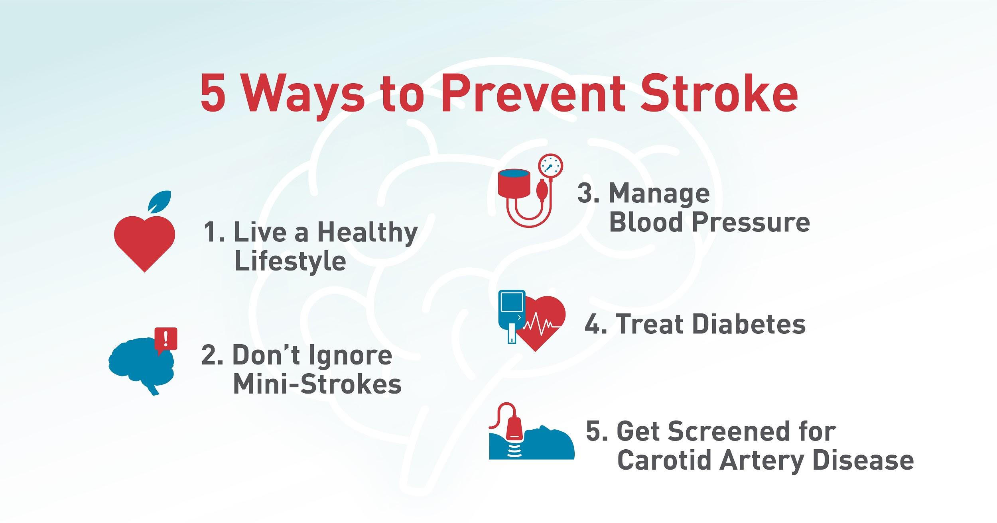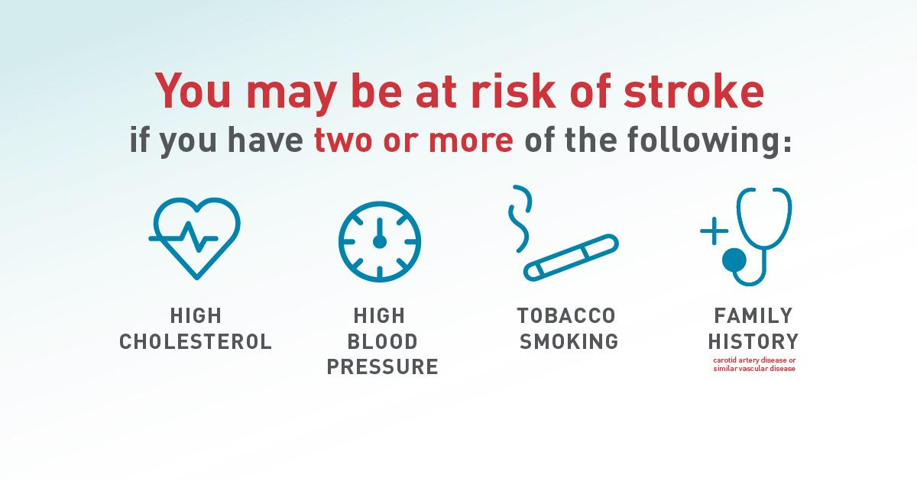

[If you would like to include an animation video of the procedure, it can be linked from https://youtu.be/O32nDoovMPY]

# # # Sample Social Media Posts # # #
Dear Dr. [Name],

Nationwide, hospitals are experiencing a 40% decline in the number of patients receiving evaluations for acute stroke (source). Even during the COVID-19 pandemic, it is important for stroke patients to get care as soon as possible to improve their chance of survival. According to the American Stroke Association, 80 percent of strokes are preventable – and a large percentage of the ones that happen are treatable with the right care, right away. With carotid artery disease estimated to be the source of stroke in up to a third of cases, I wanted to let you know about an innovative procedure now being offered at [Hospital] to treat high-risk patients with carotid artery disease.

TCAR has been studied extensively and is an FDA-cleared procedure. Over 15,000 procedures have been performed worldwide, and the clinical data has been excellent. Based on published clinical trials, the procedure offers several advantages:
Better outcomes
- TCAR results in a low periprocedural stroke rate of 1.4% in high surgical risk patients. This compares favorably to a 2.3% stroke rate of carotid endarterectomy (CEA) and a 4.1% stroke rate of carotid artery stenting from a trans-femoral approach (tf-CAS) in standard risk patients. This is the lowest reported stroke rate to date for any prospective, multi-center trial of carotid stenting.
- In a comparative study between TCAR and tf-CAS published in JAMA, TCAR demonstrated an almost 50% reduction in the relative risk for in-hospital stroke & death (1.6% vs 3.1%) and 1-year stroke & death (5.1% vs 9.6%).
Studies show the below significantly favor TCAR when compared to CEA. This is important for your patients when less time in the hospital is necessary.^{4,5,6,7}
- Less Risk of Myocardial Infarction  - Less Risk of Cranial Nerve Injury  - Less Time in OR  - Less Time in the Hospital > 1 Day | - More Likely to Discharge Home  - Less Clamp Time  - Ability to Perform Procedure with Local Anesthesia vs. General
TCAR procedures for symptomatic and asymptomatic patients at high risk for surgery are now eligible for Medicare reimbursement through the Society of Vascular Surgery sponsored TCAR Surveillance Project. This program is part of the Vascular Quality Initiative, an open registry tracking long-term clinical outcomes to promote best practices and evidence-based medicine.

If you have patients with high-grade carotid stenosis, we would be happy to see and evaluate them for TCAR. Please contact our office, [name] at [phone]. We have implemented multiple protocols to ensure the safety of your patients during this pandemic, including:
- [list COVID-19 safety protocols]

Please contact our office, [name] at [phone]. We look forward to working with you.

Sincerely,
[Doctor name]
### Referral Letter Template ###
Carotid Artery Disease Diagnosis & Treatment, Stroke, and COVID-19 Backgrounder
Every year, 15 million people worldwide suffer a stroke. Nearly 6 million die and another 5 million are left permanently disabled. While it is widely known that stroke is caused by high blood pressure, high cholesterol, smoking, obesity and diabetes, there is a lesser known condition that can be screened for in the fight against stroke: carotid artery disease (CAD).

COVID-19 and Preventing Stroke
Every 40 seconds, someone in the United States has a stroke. Even during the COVID-19 pandemic, it is important to know the symptoms (F.A.S.T.:Face, Arm, Speech, and Time) and to get care as soon as possible to improve your chance of survival and avoid permanent disability. While there are many different causes of stroke, there are simple things one can do to prevent stroke, or at least significantly reduce the likelihood of a stroke leading to permanent disability or death, including:
- Live a healthy lifestyle. This includes quitting smoking, eating a healthy diet, and exercising regularly to maintain a healthy weight. Other good habits include sleeping regularly and limiting alcohol consumption.
- Don’t ignore mini-strokes. Transient ischemic attacks (TIAs), sometimes called “mini strokes,” can cause temporary vision loss, slurred speech or weakness. About 1 in 3 people who have a TIA go on to have a stroke, often within a year, so be sure to seek medical care if you’ve suffered from these temporary symptoms or believe you’ve had a TIA.
- Treat diabetes. Diabetes can cause blood clots to form if not properly managed. For people with diabetes, high blood sugar damages blood vessels over time, increasing the likelihood that clots will form inside them. These clots can then travel to the brain, causing a stroke. People with diabetes are 2-4 times more likely to have a stroke.
- Manage blood pressure and cholesterol. High blood pressure and high cholesterol can both cause plaque build-up in your arteries, leading to heart attack or stroke. In people having a stroke for the first time, three-quarters have high blood pressure.
- Get screened for carotid artery disease. A clogged carotid artery in the neck caused by the build-up of plaque is estimated to cause one-third of strokes. If you have been diagnosed with heart disease or peripheral artery disease, you are at an increased risk for carotid artery disease, too. Other risk factors include being over age 65, smoking and a family history of stroke. Early diagnosis and treatment of a narrowed carotid artery can decrease stroke risk. Your doctor can listen to the arteries in your neck with a stethoscope or refer you for a carotid ultrasound.
Carotid Artery Disease (CAD)
Carotid artery disease is estimated to be the source of stroke in up to a third of cases, with 427,000 new diagnoses of the disease made every year in the United States alone. Carotid artery disease is a form of atherosclerosis, or a build-up of plaque in one or both of the main arteries of the neck. The carotid arteries are vital as they feed oxygen-rich blood to the brain. When plaque builds up in the carotid arteries, they begin to narrow and slow down blood flow, potentially causing a stroke if blood flow stops or plaque fragments travel to the brain.

CAD Diagnosis
Carotid artery disease is typically silent and does not present with symptoms. Physicians can screen patients based on risk factors like high blood pressure, diabetes, obesity and smoking. Sometimes, patients are screened for carotid artery disease if the doctor knows the patient has vascular disease elsewhere in the body. Blockages can also be found when a physician hears a sound through a stethoscope placed on the neck. The sound is caused by blood flowing past the blockage.

If someone is having stroke-like symptoms (weakness/numbness on one side, loss of eyesight/speech, garbled speech, dizziness or fainting), they should seek immediate medical attention and be evaluated for carotid artery disease.

The following tests may be performed if carotid artery disease is suspected:
- Carotid artery ultrasound: This test uses sound waves to produce an image of the carotid arteries on a TV screen and can be helpful in identifying narrowing in the carotid arteries. This test is painless and does not require the use of needles, dye or X-rays.

- Angiography: An angiogram uses X-rays to take a picture of the carotid artery. For the X-ray to “see” the arteries, a dye is injected through a small tube (catheter) inserted into an artery in the groin or arm. This procedure will determine exactly where the narrowing is located and will help to guide further treatments.

If carotid disease is diagnosed during one of these tests, a doctor will discuss treatment options.

Traditional Treatment Options for CAD
Treatment options for carotid artery disease depend upon the severity of the overall patient condition and symptoms. Moderate disease may not require an interventional procedure, as some individuals can manage the disease with medications and lifestyle changes. More severe blockages may require surgery. Today, there are three primary surgical approaches:
- Carotid Endarterectomy (CEA): This open surgical procedure removes plaque from inside the carotid artery in order to restore normal blood flow to the brain. The surgeon makes an incision on the neck to access the affected artery, opens the artery and removes the plaque. The surgeon will then close the artery and the incision in the neck using stitches.

- Transfemoral Carotid Artery Stenting: In this minimally invasive alternative procedure, the physician works through a tube inserted into the artery in the upper thigh. First, a small umbrella-like filter is placed beyond the diseased area of the carotid artery to help limit fragments of plaque from traveling toward the brain during the procedure. The physician then inserts a slender, metal-mesh tube, called a stent, which expands inside the carotid artery to increase blood flow to the brain and stabilize the plaque.

Innovative Treatment Approach: TransCarotid Artery Revascularization (TCAR)
TransCarotid Artery Revascularization (TCAR) is an innovative technology developed to treat patients with carotid artery disease who are at risk for open surgery.
- The entire TCAR procedure is performed through a smaller incision in the neck and in less than half the time of a carotid endarterectomy – limiting the stress on the heart and significantly cutting the risk of the patient having a stroke or heart attack during the procedure.
- During the TCAR procedure, a tube inserted into the carotid artery is connected to a system temporarily directing blood flow away from the brain to protect against dangerous debris from reaching the brain and causing a stroke during the procedure. Surgeons filter the blood before returning it to a vein in the groin, and a stent is implanted to the carotid artery to stabilize plaque and prevent strokes.
- Patients who undergo the TCAR procedure recover quickly and almost always go home the next day to return to full and productive lives with less pain and smaller scars than traditional treatments, and a reduced risk of future strokes.
- Over 15,000 procedures have been performed worldwide through clinical trial and commercial use. TCAR has been studied extensively, and the clinical data have been excellent.
Sources:
https://vascular.org/patient-resources/vascular-conditions/carotid-artery-disease
https://www.cdc.gov/stroke/facts.htm
https://www.world-stroke.org/world-stroke-day-campaign/why-stroke-matters/learn-about-stroke

# # # Carotid Artery Disease Backgrounder # # #

Interview Guide to Preventing Stroke During the COVID-19 Pandemic with TCAR
To help you prepare for media interviews regarding the COVID-19 pandemic and TransCarotid Artery Revascularization (TCAR) procedure, this tip sheet has been developed to provide background on the technology, carotid artery disease and treatment options.
Key Messages
Following are questions you may be asked, along with sample language you can use to create key messages in your own words.
Question | Suggested Key Messages
What is carotid artery disease? | Carotid artery disease is a form of atherosclerosis, or a build-up of plaque in the two main arteries of the neck. The carotid arteries are vital as they feed oxygen-rich blood to the brain. When plaque builds up in the carotid arteries, they begin to narrow and slow down blood flow, potentially causing a stroke if blood flow stops or plaque fragments travel to the brain.  Additional details:  - Carotid artery disease is estimated to be the source of stroke in up to a third of cases.  - There are 427,000 new diagnoses made every year in the U.S. alone.  - Every year, 15 million people worldwide suffer a stroke, also known as a brain attack. Nearly 6 million die and another 5 million are left permanently disabled.
What are ways you can prevent stroke? | Stroke prevention begins with maintaining a healthy lifestyle and receiving routine health checks. Smoking, diabetes, blood pressure, and cholesterol can increase your chance of having a stroke. It is important to talk to your primary care physician about your risk of having a stroke and if you should be screened, especially if you have a family history of vascular disease. Early diagnosis and treatment of a narrowed carotid artery can decrease stroke risk. Your doctor can listen to the arteries in your neck with a stethoscope or refer you for a carotid ultrasound.
During the COVID pandemic, is it safe to go to the hospital?  What precautions are you taking to keep patients safe from COVID-19? | It is important not to delay routine checkups, especially if you may be at risk for life-threatening conditions or have a family history of it.  [Hospital] has taken extra precautions to ensure our patients’ safety in both surgical and exam rooms, including:  - [list COVID protocols]
What is the TransCarotid Artery Revascularization (TCAR) procedure? | At [Hospital], we are offering a new technology called TransCarotid Artery Revascularization, or TCAR, to treat patients with carotid artery disease who are at risk for traditional open surgery. We are proud to offer this procedure to our high-risk patients, as a clinically proven, less invasive alternative to help prevent future strokes with a faster recovery time.
How does the procedure work? | - A sheath is inserted directly into the carotid artery through a small incision at the neckline.  - The TCAR system creates a reversal of blood flow. Any debris or clots that dislodge from the artery during the procedure flow away from the brain into a filter system outside of the body.  - We can now safely cross the blockage and insert the stent to open blood flow and stabilize the plaque and intended to help prevent future strokes.  - We then filter the blood and return it back into the body through a vein in the groin, remove the sheath and close the hole in the artery and neck.
Is the TCAR procedure “safe”? | Yes. TCAR has been studied extensively and is an FDA-cleared procedure. More than 15,000 procedures have been done worldwide, and the clinical data are excellent. Results from clinical trials show that TCAR has the lowest reported risk of stroke to date for any prospective, multi-center trial of carotid stenting.
What are the benefits of TCAR over other treatments? | Traditional treatment options such as carotid endarterectomy, or open surgery, and carotid artery stenting have been shown to effectively treat the blockage.  - The entire TCAR procedure is performed in less than half the time of a carotid endarterectomy – limiting the stress on the heart and significantly cutting the risk of the patient having a stroke or heart attack during the procedure.  - By reversing the blood flow during the procedure, we’re preventing any plaque that might dislodge inside the artery during the procedure from travelling up to the brain, causing a stroke.  - Patients who undergo the TCAR procedure recover quickly and almost always go home the next day to return to full and productive lives with less pain, smaller scars and a reduced risk of future strokes.
How important is this TCAR procedure for treating patients? | I am very excited about this new procedure because it’s really a great new tool in our fight against stroke. Because it’s less invasive and very safe, this procedure can help a lot more people reduce their risk for stroke. Ultimately, I see this becoming the preferred and routine way we treat carotid artery disease. Especially during this pandemic, because patients experience a faster recovery compared to open surgery.
Who created the TCAR system? | A company based out in California, called Silk Road Medical, has worked over the past 10+ years with the vascular surgery community in refining the procedure, conducting clinical trials, and are now commercializing TCAR in the U.S.
How do you know if someone has carotid artery disease? | Unfortunately, a lot of carotid artery disease is silent and does not present with symptoms. Physicians can screen patients based on risk factors like high blood pressure, diabetes, obesity and smoking. Certainly, if you are having stroke-like symptoms (weakness/numbness on one side, loss of eyesight/speech, dizziness or fainting), you should seek immediate medical attention and be evaluated for carotid artery disease.

Tips for Controlling the Media Interview
There are techniques you can use to control the flow of an interview with a reporter. These include:
- Repeat the Reporter’s Question in Your Answer – By repeating the question in your answer, it provides a complete “soundbite” that can be used by the media.
- Question: What is TransCarotid Artery Revascularization?
- Answer: TransCarotid Artery Revascularization is…
- Repeat Your Key Messages – Use one of the statements below to transition to your key message.
- The most important point is…
- Again, as you recall, what is really important is…
- As a matter of fact…
- The fact is…
- Actually….
- Manage Pregnant Pauses – When a reporter is silent, don’t feel like you have to keep talking. Instead, you can ask simple questions like the following, which put the ball back in the reporter’s court.
  - Did I answer your question?
  - Is that clear?
- Block and Bridge – If a reporter asks a question you can’t or don’t want to answer, you can use the “block and bridge” technique to return to your key messages. Following are samples of blocking and bridging statements.
Block: | Bridge:
I can’t speak to… | What I can speak to is…
I can’t speculate on… | What I do know is…
That’s not my area of expertise… | What I can tell you is…

- Wrap up the Interview – At the interview close, if the reporter asks if there’s anything else you want to say, repeat your key messages. Do not say “No, I think we’ve covered it,” or anything to decline the opportunity to repeat your key messages. If the reporter wraps up the interview, feel free to add “The last thought I want to leave everyone with is…” and repeat your key messages.
### Physician Interview Guide ###
TransCarotid Artery Revascularization (TCAR) Background & Media Interview Tips
This tip sheet has been developed to help you prepare for media interviews regarding your experience as a recipient of the TransCarotid Artery Revascularization (TCAR) procedure.
Pronunciation Guide
- Carotid Artery: [kuh-rot-id | ahr-tuh-ree]
- TransCarotid Artery Revascularization: [trans-kuh-rot-id | ahr-tuh-ree | ree-vas-kyuh-ler-uh-zey-shuh n]
- TCAR: [tee-kahr]
Anticipated Questions
Following are questions you may be asked, along with sample language you can use to create key messages in your own words. Be sure to repeat the reporter’s question in your answer; by repeating the question in your answer, it provides a complete “soundbite” that can be used by the media.
Question | Suggested Response
How did you find out you had carotid artery disease? | Describe your experience.  - For example: “I first found out I had carotid artery disease when…”
What was the TCAR procedure like? | Discuss the details of your surgery, such as anesthesia, how long you stayed in the hospital, etc.  - For example: “I had the surgery on a Tuesday and was able to go home the next day.”
Why did you decide to get the TCAR procedure done during the COVID-19 pandemic? | Discuss your thoughts on why you didn’t want to wait to receive treatment.  - For example: “Knowing I was at higher risk of having a stroke, I did not want to take any chances by waiting.”
Did you feel comfortable receiving the TCAR procedure at [hospital] during this pandemic? | Discuss how comfortable you were with the hospital and staff during your procedure and when in recovery.  - For example: “The hospital and staff were very professional and took many precautions to ensure my safety from COVID-19. They made me feel very comfortable with receiving the TCAR procedure”
How has your recovery been? | Describe what your recovery has been like.  - For example: “After the surgery, I was able to go back to doing the things I love, such as…”
How satisfied are you with your experience with TCAR? | Describe what your experience has been since the procedure.  - For example: “After recovering from the surgery, I have a small scar on my neck and peace of mind that my previously clogged artery won’t cause a stroke in the future.”
Have you gotten back to normal activities? | Describe what you’re able to do since the surgery that you couldn’t do before.  - For example: “I had my surgery X weeks/months ago. I’m now back to taking care of my family and playing with my grandkids.
What is the TCAR procedure? | Defer questions about the implant to your surgeon.  - For example: “It’s a new procedure to clear a blockage in my carotid artery. I’m not a doctor, so for details you should talk to Dr. XYZ.”
# # # Patient Interview Guide # # #

J Vasc Surgery 2015; 62:1227-35
N Engl J Med 2010;363-11-23
JAMA 2019; 322(23): 2313-2322 ⁴ROADSTER: J Vasc Surg. 2015 Nov;62(5):1227-34 ⁵Marc Schermerhorn, MD; VEITH Symposium Presentation, November 2018 ⁶M. Malas, MD; VAM Presentation 2019 ⁷CREST Trial: N Engl J Med 2010;363:11-23

